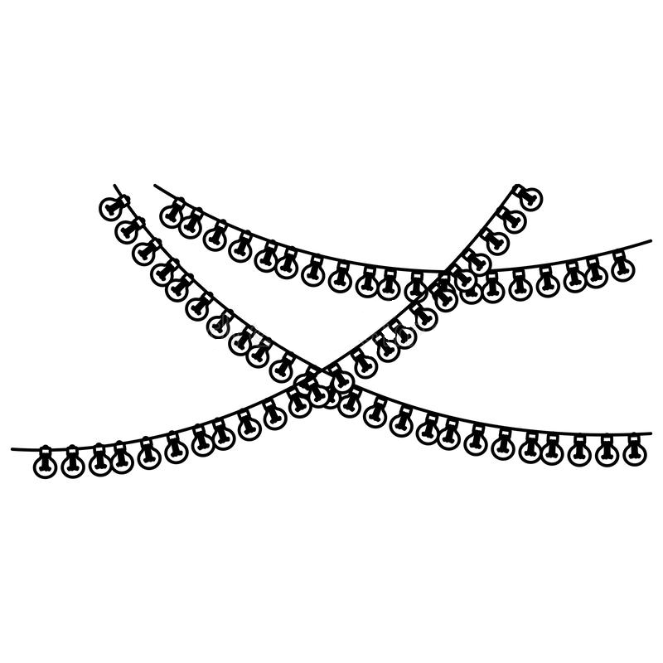

The marriage ceremony uniting

Bride and Groom’s names

DATE
CHURCH
LOCATION
Wedding Party
Officiant:
_____
Deacon:
_____
Soloist:
_____
Father of the Bride:
_____
Mother of the Bride:
_____
Mother of the Groom:
_____
Father of the Groom:
_____
Best Man:
_____
Matron of Honor:
_____
Groomsmen:
_____
_____
_____
Bridesmaids:
_____
_____
_____
Ring Bearer:
_____
Flower Girl:
_____

Joining of Hands and Exchanging of Rings
The ceremony begins with the blessing of the rings, a physical token of the vows of loving fidelity. BRIDE and GROOM turn to face each other and PRIEST NAME joins their right hands, which symbolizes their oneness, and reminds them that they are given to each other by God. The priest blesses their wedding bands and both GROOM and BRIDE help put on the other’s ring.

The Crowning
It is believed that crowns are given in heaven to those who have led exemplary lives by witnessing the true sacrificial love of God. BRIDE and GROOM are called to both perform that same sacrificial love towards one another - loving, supporting, and continuously advocating for each other. GROOM and BRIDE place their foreheads together and hold hands, showing their unity in body, soul and mind. Behind them, the Godfather of the marriage, NAME, will hold a cross above their heads, reminding the couple, and the faithful present, that Christ is watching over their marriage. This is the focal point of the wedding ceremony. The bride and groom are crowned as the “king and queen” of their own kingdom, the home, which they will guide with wisdom and love as an extension of the Kingdom of God.
The Common Cup
In remembrance of Christ’s first miracle, wine is blessed and given to the bride and groom in a “common cup.” This is the first act the newlyweds perform together. This act signifies that their marriage will be sweet and bitter, but they will share it together. It also reminds the couple that a marriage, like wine, is not made overnight, but takes years to become sweet.

“The husband and wife should be like the hand and eye. When the hand hurts, the eyes should be crying, and when the eyes cry, the hand should wipe away the tears.”

— Saint John Chrysostom, c. 349 – 407
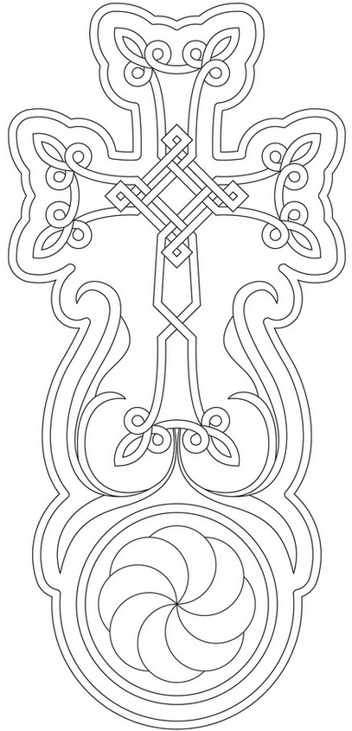

Մէկ բարձի վրայ ծերանաք:
Meg partsi verah dzeranak.
May you grow old on one pillow.
– Armenian saying

